Baby food & Infant FEEDINGS

Introducing solid foods is an important milestone in infant development. Child care providers can help infants make the transition from formula or breast milk to solid foods, in partnership with the infant's family.
Be sure to let parents take the lead on introducing solid foods, together with their child's doctor. Work with parents to set up a feeding plan. Introduce the same new foods at the same time at home and in child care. Parent will sign a waiver to have given the child the food FIRST three times at home before providing it to the child care center. Here are some guidelines child care providers can share with parents:
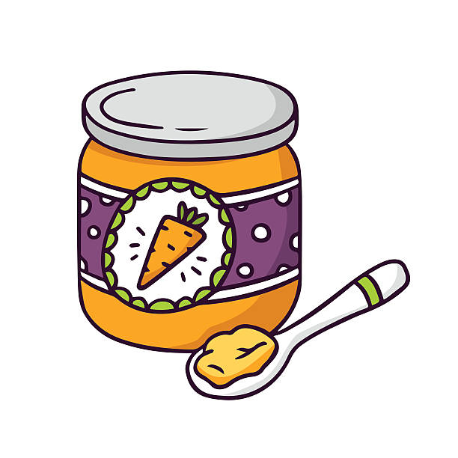
- Wait for the baby to develop certain motor skills before you start. At 4 to 6 months, babies learn to control head movements and to keep food in their mouths rather than pushing it out with their tongues. They also learn to sit up, making feeding with a spoon possible.
- Introduce solid foods at 4 to 6 months. Although breast milk and infant formula continue to be an important part of baby’s diet through 12 months, solid foods may be introduced at 4 to 6 months. These foods provide extra calories and nutrients for the older baby.
- Follow the parents' lead. Encourage parents to check with their child's pediatrician before giving babies their first solid foods.
- Start slowly. Only one or two spoonfuls of food are needed in the beginning.
- Introduce one new food at a time. Add another new food after four or five days. Waiting allows the baby to get used to new flavors and allows you to identify foods that may cause allergic reactions. (As the parents provide and set a plan).
- If the baby rejects a food, try offering it again. Babies sometimes need to try a new food several times before developing a taste for it.

Which Foods First?
(Always let the parents’ guide the food training and process- but it is good to have ideas, helpful tips, and be knowledgeable).
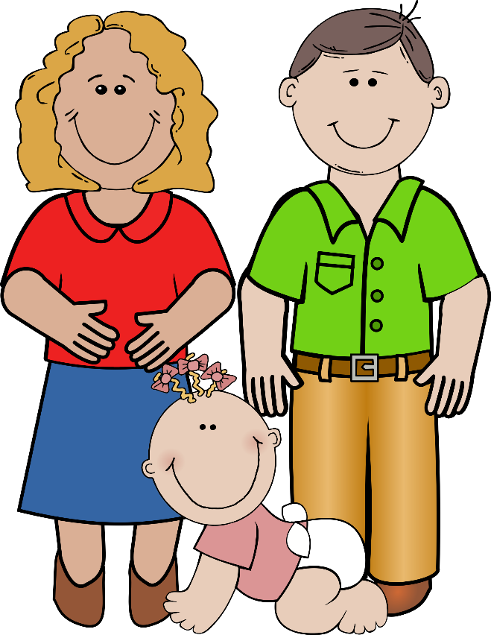
- Start with rice cereals. Rice is less likely than other grains to cause an allergic reaction. Make sure the cereal is iron-fortified. Mix it with breast milk or infant formula to provide a good balance of protein, carbohydrate, and fat to serve as a source of iron.
- Vegetables may be introduced after cereals, at about 7 months. The baby may begin to make chewing motions at this time. At this stage, cereal may be made with less formula or breast milk and mashed vegetables may be added to encourage chewing.
- Fruits should be introduced after vegetables. Use single ingredient foods such as applesauce. Combination baby foods, such as fruit desserts, cannot be counted for the Child and Adult Care Food Program (CACFP).
- Babies with one or two teeth can eat some lumpy foods. Some babies chew very well even without teeth. Foods served to the other children may be offered to the baby. Easily mashed foods, such as potatoes and carrots, bananas or canned fruits, work well. Remember though, babies do not need added sugars or salt.
- Offer soft finger foods as soon as a baby can grasp. Any food that will not fall apart between the plate and mouth is appropriate as a finger food. Try banana slices or tender cooked carrots. Finger foods are messy at first, but the mess will decrease with practice.
- Meat, egg yolks, and small amounts of cheese may be added to baby’s diet starting at 8 months. Babies should not be given egg whites before their first birthday.
- Wheat is not recommended before 8 months. Many infants are sensitive to wheat. Waiting until 8 months will help to avoid a potential allergic reaction.
- Honey and corn syrup are not recommended before 12 months. Some honey and corn syrups contain botulism spores. These are not harmful to children and adults but may produce poisons that can be fatal to babies. Infants’ digestive systems cannot destroy these spores.
- Formula, breast milk, juices, and water may be given from a cup after 10 months. Hold the cup and serve only small amounts of liquid. Only an adult should feed an infant. By the first birthday, most babies are able to handle the cup alone.

