INFANT BOTTLES AND FEEDINGS

Safe Handling of Infant Bottles in Child Care
- Label all infant bottles with the baby’s name and date. Ask parents to label bottles before bringing them. Have labels and a marker on hand in case they forget. Give parents proper color labels in advance and when they run out.
- Store prepared bottles in the refrigerator. Store each child’s bottle in the correct color coordinated basket in the refrigerator. All bottles must be mixed, prepared, and labeled from home.
- Wash your hands carefully with soap and water before preparing any bottle. Do not touch nipples with your fingers.
- Do not warm bottles in the microwave. Uneven heating may cause hot spots, which can burn a baby’s mouth. Cover all bottles during storage. All bottles will be warmed using the appropriate bottle warmer in the classroom. Formula bottles on the formula warmer, breast milk bottles on the breast milk warmer.
- Throw away any breast milk or formula left in a bottle after feeding. If too much seems to be going to waste, record the amount usually used and prepare a smaller amount. A signed waiver will need to be turned in to NOT throw away breast milk.
- Rinse bottles. Send home bottles dirty to the parents to clean, sanitize, and bring back the next day.

Appropriate Bottle-Feeding in Child Care
- Feed infants whenever they seem hungry. Babies need to eat frequently, especially if they are breastfed. Expect to feed infants approximately every two to three hours. Follow the provided set plan with the parents and communicate often if it needs to be changed.
- Meet individual infants' needs. Feed each infant on an individual schedule and don't expect all babies to be hungry at the same time. Babies grow rapidly and hunger needs change quickly.
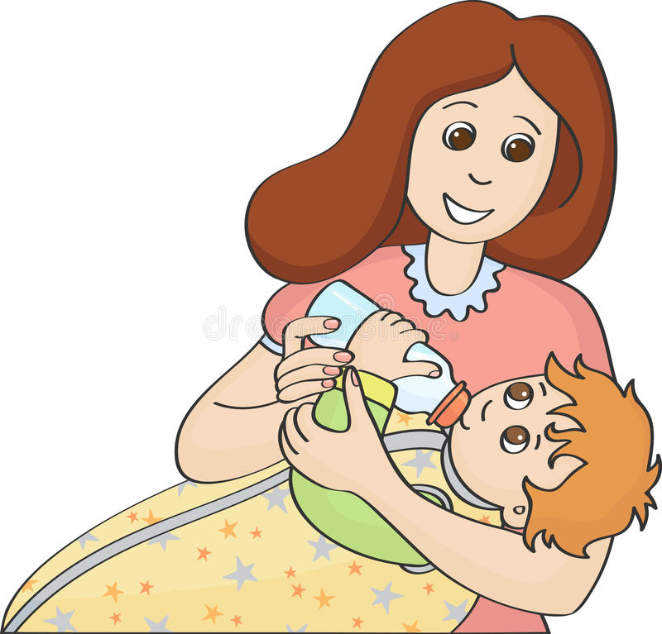
- Hold babies when you are feeding them. Holding infants during feeding helps them feel more safe and secure. Holding babies also reduces the risk of their choking on breast milk or formula. Use this as the child’s primetime and give them your undivided attention.
- Avoid giving bottles to infants in their cribs. You must only feed 1-2 babies at a time. Babies can NOT have their bottles propped up and must either hold it themselves or the care giver. If the infant falls asleep during feeding, move the baby to their crib, WITHOUT a bottle. Follow safe sleep practices.
- Never let infants or toddlers carry bottles. They easily can fall and injure themselves. Children who carry bottles may share sips with other children, which increases their risk of sharing infections.

