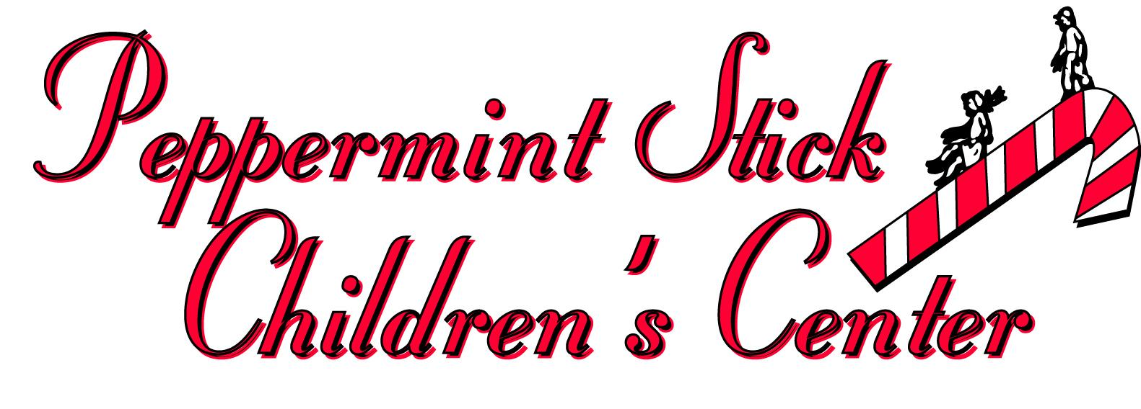

POLICY: Remote working policy POLICY NO.: 4.4 EFFECTIVE DATE: 4/2020
Our remote employees must follow all our company’s policies like their in-center colleagues
To ensure that employee performance will not suffer in remote work arrangements, we advise our remote employees to:
  - Choose a quiet and distraction-free working space.
  - Have an internet connection that’s adequate for their job.
  - Dedicate their full attention to their job duties during working hours. (Work hours may be flexible and reduced from working in the center. Work hours may be chosen daily based on when it is best for the employee to dedicate their full attention to their work assignments i.e., evenings or early morning).
  - Adhere to break and attendance schedules agreed upon with their Director. Employees must have Director approval to work more than their average work hours in an assigned week.
  - Ensure their schedules overlap with those of their team members for as long as is necessary to complete their job duties effectively.
  - Directors will determine long-term and short-term goals depending on the needs of the school. They should frequently meet/communicate (either online via email, zoom or in-person when possible) to discuss progress and results.
Expectations-
- Remote employees should –
- Check their email daily for updated assignments, announcements etc.
- Write clear emails and reports that minimize back-and-forth communication.
- We understand the struggle of work life balance right now but this offers flexibility in maintaining employment. Tasks may be completed daily during a time that is convenient for you but due dates are expected to be followed.
Compensation and benefits-
Compensation is determined by job role. Currently, (for the month of April 2020) all remote workers are entitled to an average of their hours worked in the first quarter of 2020. However, compensation for not meeting assigned work tasks will result in a reduction in pay to minimum wage during the duration of remote work. If an employee continues to miss assigned remote work tasks after a formal warning, they may be required to work their average hours in the facility where needed (Either Round Lake or Grayslake). Refusal to work will signify the abandonment of their job and Peppermint Stick will take this action as their resignation.

