Go to: www.ilgateways.com

Login

Click on My Registry | 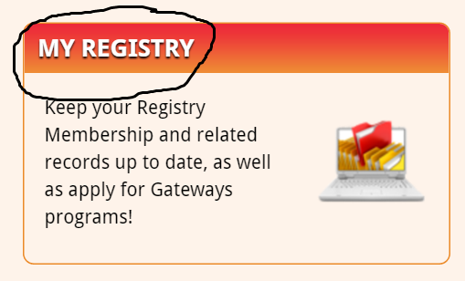
Click on LEARN | 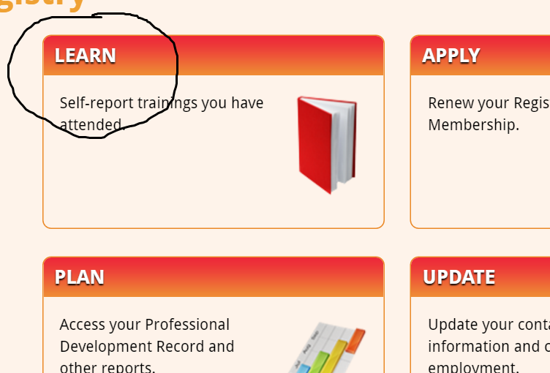
Scroll to bottom- Click ADD NEW | 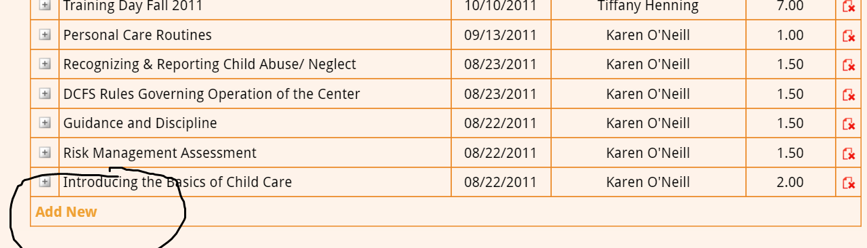
Fill out information from Training Certificate  & Save  Repeat for all trainings | 