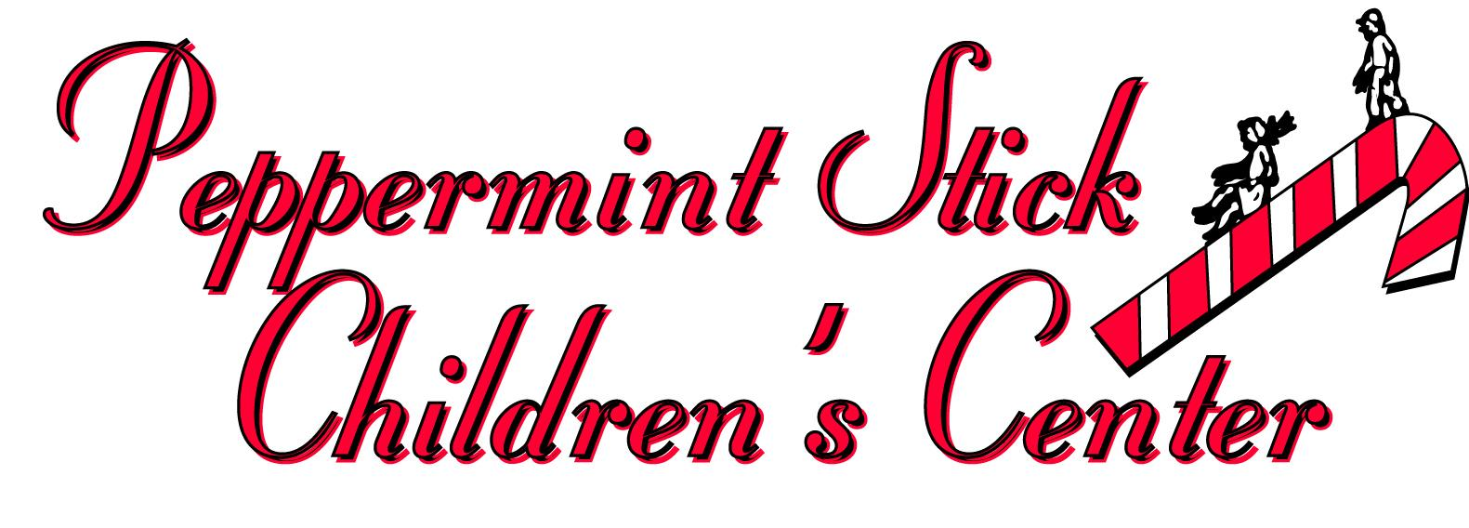

4/1/2020

Staff,

I have spent the last 34 years working for Peppermint Stick. There is nothing that has specifically prepared me for this moment. I have experienced recessions, low enrollment, glitches with the government funding, staffing crisis, polar vortex, car crash Bob that hit our building, power outages that disrupted business, flooding, small fire, equipment failure etc. But nothing of this magnitude. I take making decisions that affect so many people, very seriously.

When I hear things thrown around like the owners don’t care or they are only doing this for the money, it really hurts. If I was doing this for the money I wouldn’t be here, I would be a full time early childhood professor at a university. But I love what I do. Providing a safe, loving environment to these children fills my heart. Helping a family or a coworker feel safe, respected and important matters to me more than any paycheck will ever bring me satisfaction.

Just like I have to make the best decisions for me and my family, I know you will have to make tough choices too. As many of you know, Ms. Maria called Round Lake families over the past week to see how they were doing. Many are scared, worried how long they will have to stay home. Worried if they will lose their jobs because they have no one to watch their kids. Worried they will not be able to keep their car or house. Worried about the unknown and worried about getting sick etc. I am sure many of you can relate to at least one or two or maybe even all of them.

Through our surveys and calls we have 32 children as of today that need care immediately. Many do not have the option to work from home and frankly our job doesn’t provide many opportunities to do that either. We have decided that we need to open one of our centers as an emergency licensed center and the need is greater at Round Lake. We have sent in the paperwork to get this license approved. We feel for many reasons this is necessary. For some of our children food and safety in the terms of abuse, neglect and supervision is an issue. Being at our center will provide them with these basic needs. My one guiding rule that I use is “what is in the best interest of the children”. Number one is to stay home but for those that can not, I believe that the care we offer is important to our kiddos. Would I want to see one of our young children who has already seen their world drastically change in the last month, end up in another emergency daycare center across town in a classroom of strangers. (There are currently 8 centers in a 10 mile radius open and numerous home licensed centers) Many of our children have already experienced traumatic stress and some even abuse in their lives. We know that this can lead to ongoing emotional upset, depressive symptoms or anxiety, behavioral changes, difficulties with self-regulation, problems relating to others or forming attachments and so on. This is actually a time when the children need us the most, to reassure them and to provide consistency and love.

This situation isn’t forever but even when the shelter in place is lifted the virus will still be around. SO this is something we will be dealing with for a while. It is a delicate balance of reducing risk and being able to pay our bills. I want to be accommodating and flexible with all of you impacted by government-imposed quarantines and our new way of life for the foreseeable future. Please respond to me with your questions and concerns and we will try to figure this out together.

So within the next week we may need staff to come into the school to prep and train for our reopening in Round Lake. If any Grayslake staff want to volunteer to work at Round Lake please email or text Ms. Jessica. If we find that we need Grayslake staff at Round Lake due to being short staffed or an increase in the number of Grayslake children attending then you may be scheduled to work. As an emergency center we are entitled to a stipend/bonus from the State of Illinois. Depending on the number of classrooms we open determines how much we will be paid. That money will be cash bonuses for all those staff working directly in the classroom with children during the shelter in place.

We all will undergo new training on health screenings including temperatures (2 new non-contact infrared thermometers have been purchased), new rules for reduced group sizes and non mixing children during the day, guidelines for parents and staff entering the building. (Parents will also be temperature checked and not allowed to leave their child if they have a fever). We will look into a rotating scheduling that will reduce your exposure as well. We will close early every night to sanitize the center and much more.

This is unchartered territory. Thank you for your cooperation and assistance with these restrictions and for all the work you do each day to meet the needs of the children and their families.

Sincerely,
Ms. Tiffany

P.S. - My advice that I give to my college students is to consider the source of information. Facebook, blogs, “my cousin works at the hospital” etc., you have probably seen many postings on social media that are similar. You should refer to the authorities for verified, scholarly, research-based information that comes from the “experts” in the field. Do not rely on internet sources like about.com and other web-based sources. Anyone can put just about anything on a web site, and you have no sure way of knowing if it is truth or fiction. Like the advice on social media to hold your breath for 10 seconds to determine if you are free of the virus since you do not have shortness of breath. That comes from a “Doctor” in South Korea. Ummm no thanks. I’ll go to the CDC, the American Academy of Pediatrics and so on.

Pandemic Policy

Purpose:
Peppermint Stick strives to provide a safe and healthy workplace for all employees. This pandemic policy outlines our overall response to a pandemic outbreak and our emergency preparedness and business continuity plan. It outlines specific steps Peppermint Stick takes to safeguard employees' health and well-being during a pandemic while ensuring PSCC's ability to maintain essential operations and continue providing essential services to our customers. In addition, it provides guidance on how we intend to respond to specific operational and human resource issues.

Infection-Control Measures
Peppermint Stick takes a number of steps to minimize, to the extent practicable, exposure to and spread of infection in the workplace, which is an ideal site for contagion because of staff and children's close proximity to one another. As appropriate, PSCC recommends measures that employees can take to protect themselves in and outside the workplace and encourages all workers to discuss their specific needs with a family physician or other appropriate health or wellness professional.

Ill employees:
PSCC expects employees who contract COVID-19 or have been exposed to infected family members or others with whom employees have been in contact to stay home and seek medical attention as necessary and appropriate.
PSCC expects such workers to notify us as soon as possible of exposure or illness. At our discretion or the direction of outside authorities (Lake County Health Department), we can require isolation and quarantine.

Mandatory employee training: All employees are at risk of exposure to viruses, both in and outside the workplace; therefore,PSCC requires all employees to attend initial or refresher training to become informed about what to do when an outbreak occurs. Initial OSHA and PSCC Health & Safety procedures training were conducted during employee orientation. Training, which is customized for our business addresses information summarized in this document like steps to take if exposure is suspected; company representatives to whom to report known or suspected exposures, and procedures for reporting exposure to co-workers, family members, friends, or others who are ill; proper use of PSCC’s provided personal-protection equipment; proper hygiene in the workplace and at home; and communications. Directors are responsible for recording and maintaining documentation on every employee's participation in required training.

Personal-protection equipment:
PSCC maintains on site adequate supplies of recommended personal-protection equipment, such as eye protection, rubber gloves, bleach/Odoban and anti-bacterial hand gels and soap, which PSCC can require workers to use.

Facilities maintenance:
PSCC Facilities manager, Mr. Brian Hill, regularly inspects the workplace for signs of heating, air conditioning, or other equipment in need of replacement or repair. He coordinates closely with PSCC's Owners to maintain our physical buildings in good condition. PSCC approves the installation or use wherever possible of improved equipment or cleaning methods to guard against the spread of infection in the workplace.

Employee Leave and Pay In the event of pandemic:
PSCC will look into all programs provided by the state and federal government to keep the business viable and able to continue to pay the employees. If this is not feasible employees will be told to file unemployment if they are furloughed / layed off.

Family and medical leave:
If applicable, and based on current government rulings for business under 50 employees, PSCC may place employees on family and medical leave any workers who fall ill or must be absent from work to care for an infected family member. PSCC requires such employees to notify PSCC as soon as possible of the need for leave. PSCC will follow the Lake County Health Departments guidance for dealing with employees being exposed to viruses. PSCC allows employees to use accrued annual Paid Time Off (PTO) in lieu of unpaid family and medical leave. PSCC may require employees to take unpaid family and medical leave once all accrued paid leave is used. PSCC will apply for government assistance to continue to pay employees for a leave if this is possible. It is PSCC's desire to continue to employ all staff during a pandemic and continue to pay wages if feasible.

How is the current COVID-19 coronavirus transmitted?
People can catch COVID-19 from others who have the virus. The disease can spread from person to person through small droplets from the nose or mouth which are spread when a person with COVID-19 coughs or sneezes. These droplets land on objects and surfaces around the person. Other people then catch COVID-19 by touching these objects or surfaces, then touching their eyes, nose, or mouth. Therefore, it is important to frequently wash your hands.
What steps can we take now to minimize risk of transmission?
Repeatedly, creatively, and aggressively encourage employees and others to take the same steps they should be taking to avoid illness. For the annual influenza, SARS, avian flu, swine flu, and now the COVID-19 coronavirus, the best way to prevent infection is to avoid exposure. The messages you should be giving to your employees are:
- Wash your hands often with soap and water for at least 20 seconds. If soap and water are not available, use an alcohol-based hand sanitizer
- Avoid touching your eyes, nose, and mouth with unwashed hands. This is key! The virus gets into your body through your eyes, nose and mouth. Do not touch your face. Putting your hair back to avoid it getting in your face is advisable so you don't touch your face by removing your hair.
- Cover your cough or sneeze with a tissue, then throw the tissue in the trash.
- Clean and disinfect frequently touched objects and surfaces.
What we as your employer will be doing -
- Ensure that employees have ample facilities to wash their hands, including water and soap, and that cleaning/custodial schedules are accelerated. We will close at 5:30 every night to sanitize the school.
- Evaluate your remote work capacities and policies. This is harder but we may require work from home such as gateway training, planning or weekend or evening work in classrooms after hours, if needed.
- staggering employee starting and departing times, and requiring staff to work less days but perhaps longer days to reduce exposure over time.
- Follow updates from the CDC and the World Health Organization (WHO) regarding additional precautions.

